ISYS1055/1057/3412 (Practical) Database Concepts
Assessment 1: Database Design

Student Name: Syeda Shabnam Khan
Student ID: 4020189

Task 1: Designing an Entity-Relationship Model
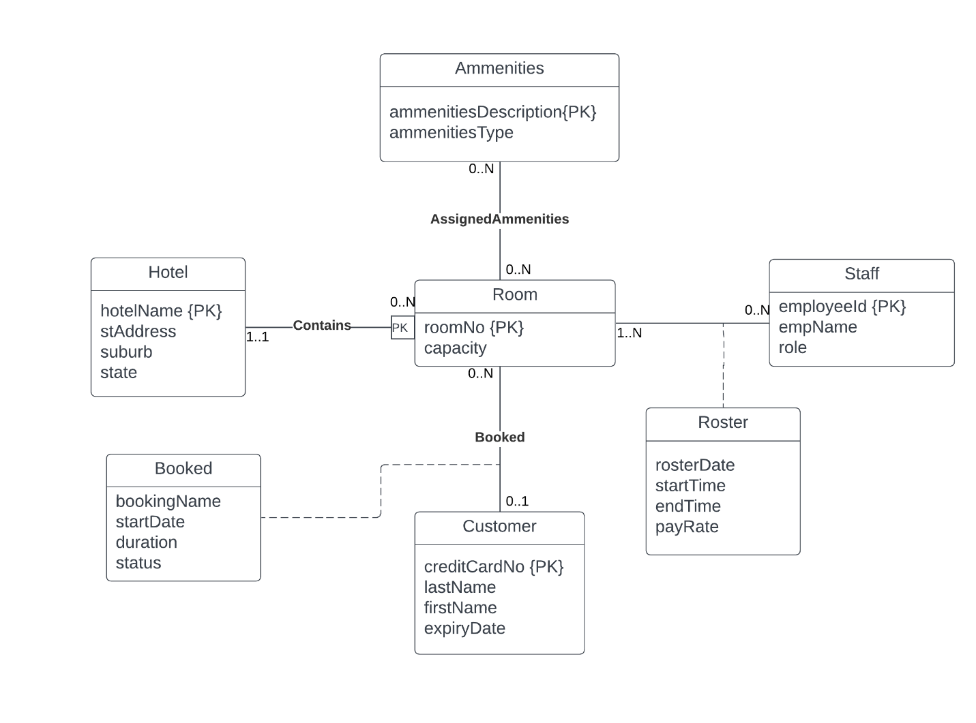
Assumptions:
- Hotel name is unique.
- stAddress has number and street name.
We cannot show the foreign keys and therefore, foreign key constrains within the ER model.

Task 2: Designing an Entity-Relationship Model

Part A: Initial Design
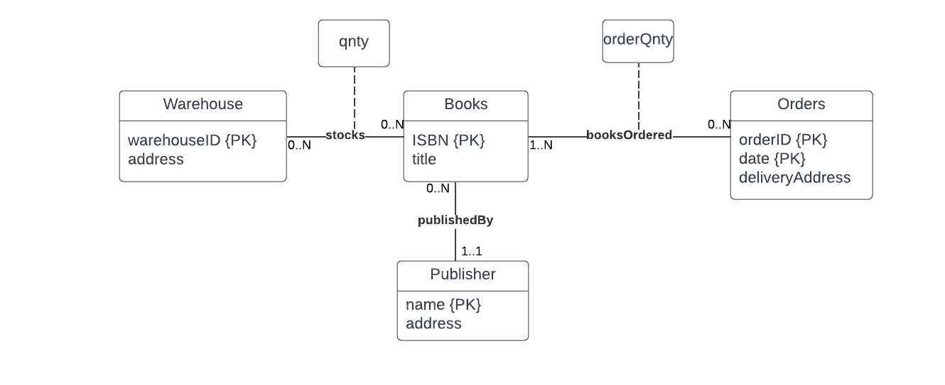
Assumptions:
- ISBN is unique.

Part B: Client Adjustments
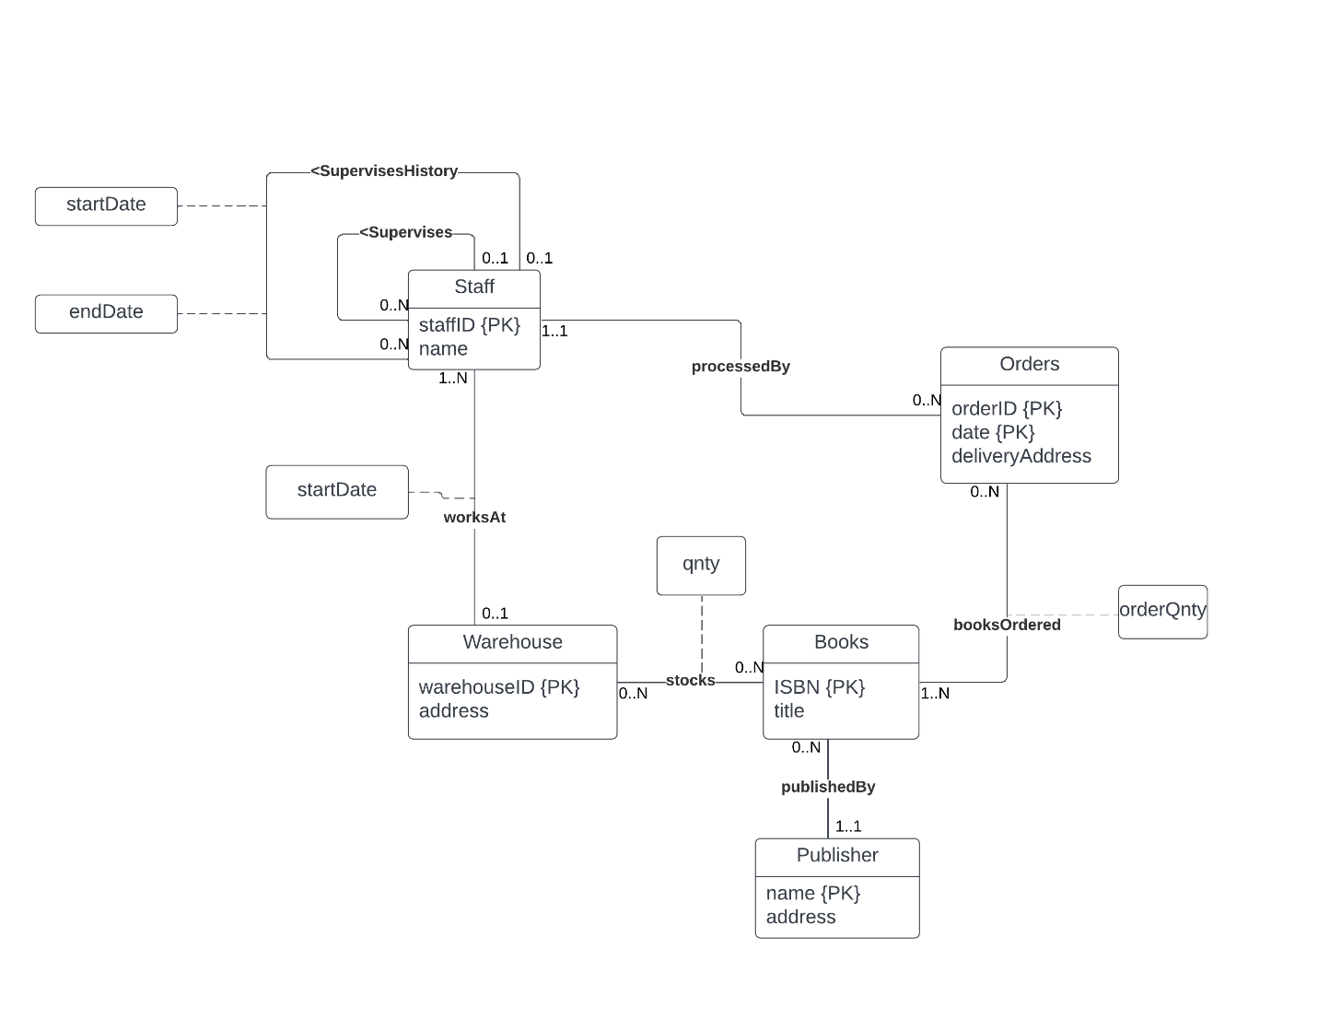
Assumptions:
- A supervisor may supervise many employees at the same time

Task 3: Mapping an ER Model to a Relational Database Schema
Step 1: Strong entities
Vehicle (regoNo, make, model, year)
Mechanic (empID, name)
Part (partNo, supplier, description, cost)

Step 2: Weak entities
Service (regoNo*, date, time, duration, fee)
Issue (regoNo*, date*, time*, name, description, outcome)
Issue (regoNo*, date*, time*, name, description, outcome, empID*)

Step 3: One to One relationships
No one to one relationship

Step 4: One to many relationships
Supervisor (employeeID*, name, date, employeeID*)
Mechanic (empID, name, empID*, date)
Issue-Mechanic(regoNo*, date*, time*, name, empID*)

Step 5: Many to many relationships
Install (regoNo*, date*, time*, name*, partNo*, supplier*, fee)

Step 6: Multi-valued attributes
None

Step 7: Higher order relationships
None

Final Schema:
Vehicle (regoNo, make, model, year)
Part (partNo, supplier, description, cost)
Service (regoNo*, date, time, duration, fee)
Issue (regoNo*, date*, time*, name, description, outcome, empID*)
Mechanic (empID, name, empID*, date)
Install (regoNo*, date*, time*, name*, partNo*, supplier*, fee)

Task 4: Relational Database Model
4.1: No. superEmpID is not a primary key, therefore, it can have NULL as a value. Hence an employee may or may not have a supervisor.
4.2:
Employee.superEmpID -----> Employee.employeeID

Employee.employeeJobID -----> Job.jobID

Employee.departmentID -----> Department.departmentID

Employee(employeeID, firstName, lastName, phoneNumber, hireDate, empJobID*, salary, departmentID*, superEmpID*)

4.3: This is not sufficient. Removing the department does not remove the employee working in the department from the employee entity. The employee must be removed from the employee entity and JobHistory entity. Moreover, the location with the locationID 30 also has to be removed from the location table as the department in that location no longer exists.

4.4: Two or more employes may share the same phone number therefore, updating the table by phone number will also update the information for the other employees. Instead of using phoneNumber, a better way is to use the employeeID which must be unique.

The past contracts of Jonny Deans can still be seen by accessing the JobHistory table using his employeeID. The SQL query as follows:

SELECT * FROM JobHistory WHERE employeeID = 10;

4.5: The SQL statement will access the Department table and change the DepartmentID of IT services from 1 to 4. This change will also effect the Employee and jobHistory table as DepartmentID is a foreign key in both.

4.6:
CREATE TABLE Location (
LocationID INTEGER NOT NULL PRIMARY KEY,
streetAddress TEXT,
postalCode INTEGER,
city TEXT,
stateProvince TEXT,
countryID INTEGER,
FOREIGN KEY (countryID) REFERENCES Country(countryID)
);

4.7:
CREATE TABLE Country (
countryID INTEGER NOT NULL PRIMARY KEY,
countryName TEXT
);

4.8:
INSERT INTO Employee (employeeID, firstName, lastName, phoneNumber, hireDate, empJobID, salary, departmentID, superEmpID),
VALUES (99, ‘John’, ‘Smith’, ‘0123’, ‘01-01-2022’, 66, 200000, 4, NULL);

INSERT INTO Department(departmentID, departmentName, managerID, locationID)
VALUES (4, Management, 99, 10);

UPDATE Employee SET superEmpID=99 WHERE employeeID=12;

UPDATE Employee SET superEmpID=99 WHERE employeeID=66;

UPDATE Employee SET superEmpID=99 WHERE employeeID=18;

INSERT INTO Job(jobID, jobTitle, minSalary, maxSalary)
VALUES (66, CEO, 150000, 250000);

